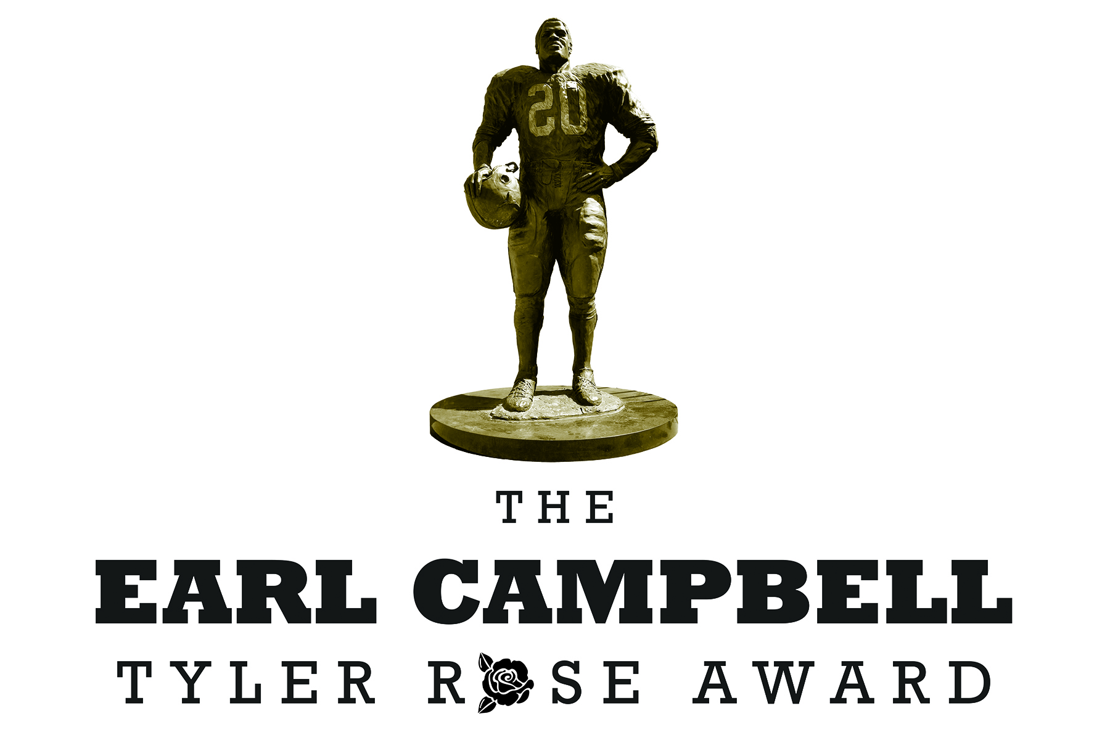

NEWS RELEASE
January 17, 2014 Contact Information:
Cindy Smoak
Phone: (903) 592-1661 x237
Fax: (903) 592-1268
Email: csmoak@tylertexas.com

TYLER, Texas – The Tyler Chamber of Commerce and SPORTyler announced today Bryce Petty, Baylor Quarterback, as the first-ever recipient of the 2014 Earl Campbell Tyler Rose Award presented by Earl Campbell. Petty received the award at The Earl Campbell Tyler Rose Award Banquet January 17, 2014.

“I’m honored to present the first award to Bryce Petty,” Earl Campbell said. “The votes were close, but Bryce had an amazing season, and we were proud to celebrate his achievements at the banquet.”

The Earl Campbell Tyler Rose Award was announced in 2012 to recognize the top offensive player in Division I football who also exhibits the enduring characteristics that define Campbell: integrity, performance, teamwork, sportsmanship, drive, community, and tenacity; specifically tenacity to persist and the determination to overcome adversity and injury in pursuit of reaching goals.

In his first year as the starting quarterback at Baylor, Petty had one of the greatest seasons in school history. The junior from Midlothian, Texas, passed for 4,200 yards with 32 touchdowns, while completing 62% of his passes and only throwing three interceptions.

Petty, named an All-American by Athlon and SI.com, received Big 12 Offensive Player of the Year honors from seven publications and was a unanimous All-Big 12 1st team selection.

With Petty under center, Baylor won the most games in school history (11), clinched its first Big 12 championship and earned the program’s first BCS bowl berth.

The Bears finished the season 11-2 and 8-1 in Big 12 play, the most wins in league play in BU history.

Petty was also a semifinalist for the Maxwell, O'Brien, and Walter Camp Awards and threw for at least 200 yards and two touchdowns in each of his 13 starts.

Petty graduated in May 2013 with a degree in Health Science Studies and is currently taking graduate classes.

About The Earl Campbell Tyler Rose Award
The Earl Campbell Tyler Rose Award, announced in 2012 by the Tyler Chamber and SPORTyler, recognizes the top offensive player in Division 1 football who also exhibits the enduring characteristics that define Earl Campbell: integrity, performance, teamwork, sportsmanship, drive, community, and tenacity; specifically tenacity to persist and determination to overcome adversity and injury in pursuit of reaching goals.
In addition, the nominee must meet one or more of the following criteria: born in Texas and/or graduated from a Texas High School and/or played at a Texas-based junior college or four year D1 Texas college.
For more information about The Earl Campbell Tyler Rose Award go to www.earlcampbellaward.com or contact Cindy Smoak, SPORTyler, Tyler Area Chamber of Commerce: csmoak@tylertexas.com or 903-592-1661, extension 237.
Get the most up-to-date information by following us on social media at twitter.com/campbellaward or facebook.com/campbellaward.

